DEVELOPMENT AND USABILITY OF “OMP DIGICOACH”: A DIGITAL APPLICATION FOR WORKPLACE-BASED ASSESSMENT

INTRODUCTION & LITERATURE REVIEW: Workplace-based learning (WBL) is a fundamental component of medical education, including both under-graduate and post-graduate teaching. It facilitates the development of clinical reasoning, decision-making, and professional competencies in real-life clinical environments.¹ Particularly in post-graduate medical education, clinical reasoning and patient management skills are integral components of teaching. However, in busy clinical settings it is often challenged by time constraints, heavy patient load, and inconsistent feedback practices, leading to variability in teaching effectiveness.²
The One-Minute Preceptor (OMP) model, introduced by Neher et al. in 1992, is a learner- centered model providing a structured five-step framework for efficient clinical teaching,³ Figure 1. Studies have demonstrated that OMP enhances teaching efficiency, improves feedback quality, and strengthens clinical reasoning among learners.

Despite its proven effectiveness, implementation of OMP and other workplace-based assessments (WPBA) remain inconsistent due to lack of structured prompts and reliance on memory during busy clinical workflows. ⁴Additionally, user acceptability and engagement are essential to the success of any medical education innovation. There is resistance in operationalizing of these toolkits both from teacher and learner side due to insufficient time available for undertaking these assessments in postgraduate training programs. ⁵

Digital learning tools have shown promising results in medical education. A systematic review by Dunleavy et al. reported that mobile learning is as effective as traditional methods.⁶ Technology-based mobile applications are effective tools in enhancing knowledge and skills. In today’s era they are preferred due to their low expense, high versatility, ease of availability, and flexible learning features of mobile apps.⁷ To transform the WPBA tools into digitized versions, feasibility demands that a small tool be used in the pilot project, like OMP. To date there is no mobile application specifically designed to operationalize the OMP model in real-time clinical settings.

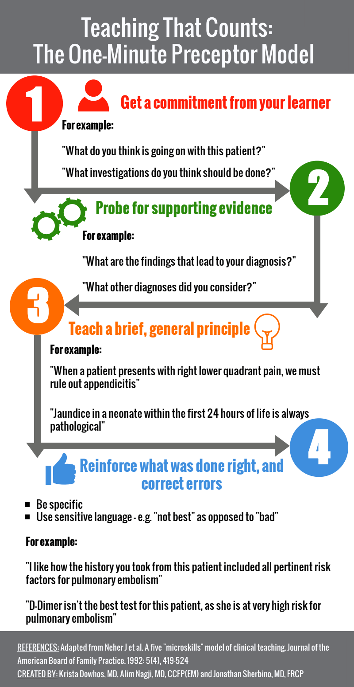
Figure. 1

2. RATIONALE
The OMP model is a well-established, evidence-based tool for efficient clinical teaching of postgraduates. However, its underutilized in WBL due to time constraints, reliance on memory, and lack of structured real-time support.
Mobile applications are gaining popularity in recent era of integration of technology in medical education by offering a practical solution to support teaching in busy clinical environments. Despite the effectiveness of both OMP and mobile digital learning tools, there is currently no evidence on interventions that combine these two approaches together.
This innovative pilot study seeks to bridge the gap between theory and practice by developing a mobile-based application named “OMP DigiCoach” to facilitate structured, time-efficient clinical teaching.
PHASE 1: DEVELOPMENT OF OMP DIGICOACH: This phase will focus on the design and development of the mobile-based application.
1. Conceptual Design: The application will be developed based on the five microskills as shown below of the OMP model, ensuring alignment with established principles of clinical teaching.
2. Instructional Structuring: Each step of OMP will be translated into interactive prompts, including:
- Commitment elicitation
- Diagnostic reasoning probing
- Teaching key principles
- Reinforcement of correct responses
- Correction of errors
3. Technical Development: The application will be developed in collaboration with software engineers and UI/UX designers at NUST, ensuring user-friendly interface, mobile compatibility and real-time functionality
4. Integrated Features: The application will include following:
- Stepwise guided teaching prompts
- Built-in timer (60-second model)
- Star-based learner rating system
- Encounter logging feature
- Dashboard for teaching analytics
5. Content Validation: The application content will be reviewed by 3 experts in medical education. Using the OMP DigiCoach Assessment Scale on a 1 to 5 rating scale for Content validity and face validity. Content validity will be calculated by CVI and face validity by expert review process.

PHASE 2: PILOT TESTING (Feasibility Testing)

Pilot testing will be done to assess the reliability of OMP Digicoach. 10 senior clinical supervisors will be requested to use OMP DigiCoach and the questionnaires during routine clinical teaching encounters. This is aimed to assess practicality of use, workflow integration, time required per encounter, completion of all OMP steps, technical issues and user engagement

Data collected during the pilot testing will follow the same process as for during the study.

Any gaps identified during pilot testing will be addressed accordingly.
PHASE 3: SYSTEM USAGE & ASSESSMENT USING SUS: This phase will assess the usability of the application. A group of 10 senior clinical supervisors will be recruited from Shifa International hospital and PAF Hospital Islamabad. Participants will use the application during routine clinical teaching encounters. Usability will be evaluated using the System Usability Scale (SUS), a validated 10-item instrument with scores ranging from 0 to 100, Appendix I. Any usability issues identified will be used for refinement of application prior to implementation.
PHASE 4: PRE–POST INTERVENTION STUDY: This phase will evaluate the usability of OMP DigiCoach.
1. Pre-Intervention Assessment: Baseline data will be collected using a structured questionnaire, OMP-Digicoach Awareness scale, Appendix II:
- Current teaching practices
- Awareness and use of OMP
- Challenges in teaching
2. Intervention Phase: Participants will receive:
- Brief orientation and demonstration session on OMP DigiCoach use
- They will then use the application during routine clinical teaching for 4 weeks.
3. Post-Intervention Assessment: Following the intervention period, participants will complete same structured questionnaire (for comparison)

